Coursework Proposal: Cultural Heritage Site Management System

Module: CS107.3 - Object Oriented Programming with C#
Module Leader: Anton Jayakody
Group: C
Institution: NSBM Green University (BSc Honours Software Engineering)
Submission Window: 2nd Week of June 2026

- Team Composition
- S A Y Randhinu - Student ID: 38677
- K T Damhiru - Student ID: 38035
- W A A S H Weerasooriya - Student ID: 37910
- T O H Jinasinghe - Student ID: 38440
- Member 5
- Member 6
- Members 7 & 8
- Member 9
- Problem Statement

- Managing and preserving Sri Lanka's historical and archaeological sites currently relies heavily on disjointed, manual tracking systems. Site managers lack a centralized platform to monitor artifact conditions, track visitor capacity, and efficiently allocate tour guides. This project will deliver a unified, interactive C# application targeting the .NET framework to solve these logistical bottlenecks, providing a localized solution for heritage site management.

- System Scope & Core Requirements

- Given the rapid development timeline, the project will focus strictly on high-impact modules that demonstrate comprehensive Object-Oriented Programming (OOP) concepts and database integration.
- Artifact Inventory (CRUD & OOP): A centralized system to log artifacts. This will utilize inheritance (e.g., a base Artifact class with subclasses like Relic and Inscription) to fulfil advanced OOP criteria.
- Visitor & Tour Guide Management (Relational Database): Modules to register visitors and assign them to specific tour guides based on time and date. This will demonstrate the system's ability to handle complex relational data.
- Interactive Analytics Dashboard: A main UI hub displaying live metrics such as total daily visitors and available guides to ensure an interactive user experience.

- Unique Innovative Feature: Smart QR Code Ticketing

- To fulfil the requirement of incorporating a unique feature that sets the system apart, the application will include an automated QR Code Ticket Generator. Utilizing the QRCoder library, the system will extract relational visitor and guide data from the database and generate a downloadable digital QR ticket. This enhances the modern visitor experience and demonstrates advanced file manipulation and third-party library integration.

- Implementation Plan & Timeline

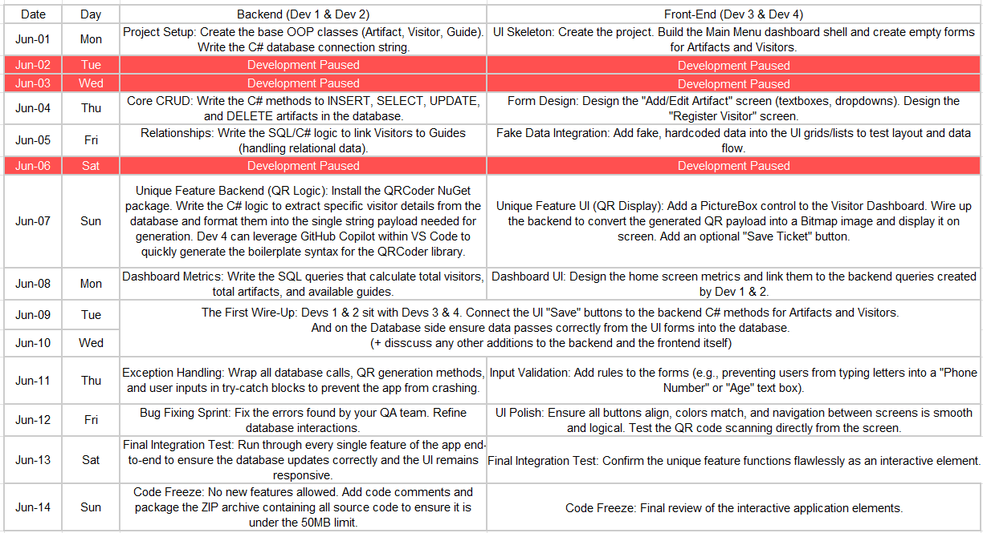
- Development will follow a rapid two-week sprint framework starting June 1, 2026. The workload is strictly isolated between backend architecture and UI design to prevent merge conflicts, with targeted integration days.

